

### 



### METHODS Unit 1

### YEAR 11

### TEST 2 : CHAPTER 3 - 6

Functions, Linear functions, Quadratic functions and equations

### Question/Answer Booklet

Student Name : ______________________________

Teacher : Mrs Erna Burger

## Time allowed for this paper

Working time: fifty minutes

## Materials required/recommended for this paper

##### *To be provided by the supervisor*

This Question/Answer Booklet

Formula Sheet

##### *To be provided by the candidate*

Standard items: pens, pencils, pencil sharpener, eraser, correction fluid/tape, ruler, highlighters

Special items: Drawing instruments, one A4 double-sided page of notes, templates and 3 calculators satisfying the conditions set by the Curriculum Council.

## Important note to candidates

No other items may be used in this section of the examination. It is **your** responsibility to ensure that you do not have any unauthorised notes or other items of a non-personal nature in the examination room. If you have any unauthorised material with you, hand it to the supervisor **before** reading any further.

Answer **ALL** questions.

Show all working clearly, in sufficient detail to allow your answers to be checked readily and for marks to be awarded for reasoning. Incorrect answers given without supporting reasoning cannot be allocated any marks.

**Mathematics Methods 1: Test 1 Non-Resource Section**

Functions, Linear functions, Quadratic functions and equations

**Time for this section:** 30 minutes **Marks for this section: 26**

**No calculators** or notes allowed for this section.

**1. [8 marks]**

The display on the right shows lines labelled **A** to **F**.

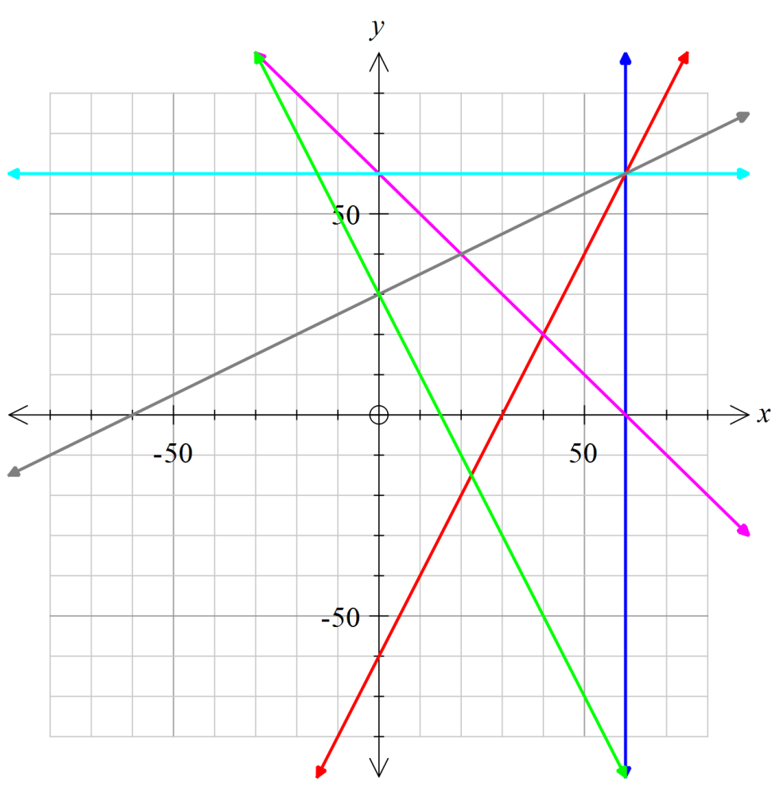

**A**

**B**

**C**

**D**

**E**

**F**

**(a)** Give the equation of line **D**: **(1)**

**(b)** Which one of the given lines are

perpendicular to line **D**?

Why? **(2)**

**(c)** Give the equations of another

set of the given lines that are

perpendicular. **(2)**

**(d)** Complete: The gradient of the line that goes through the point (20, –20) is ________

(number value) and the coordinates of the *y*–intercept is _________. This line intersect

a few other lines; give the equation of such a line: _______________________. **(3)**

**2. [12 marks]**

The graphs of functions f(*x*) = – *x* 2 + 2*x*

and g(*x*) = *x* 2 – 4*x* are shown below.



Use the graphs to answer the following questions:

1. Give the equation of the axis of symmetry of f(*x*). **(1)**
2. What is the coordinates of the turning point of g(*x*)? **(1)**
3. Find the constant value(s) of *k* where f(*k*) = g(*k*). **(2)**
4. For the graph of h(*x*) = –(*x* – 1)(*x* – 2) determine

**(i)** the nature and location of the turning point **(2)**

**(ii)** the coordinates of the *y*–intercept **(2)**

**(iii)** the coordinates of the *x*–intercept(s) **(2)**

**(iv)** Show these features on the grid above. **(2)**

**3. [6 marks]**

For f(*x*) = $\sqrt{x+2}$ and g(*x*) = 2*x* – 1 , determine each of the following:

**(a)** the natural domain and corresponding range of f(*x*). **(2)**

**(b)** g(–1) **(1)**

**(c)** the value(s) of *r* given that f(*r*) = *r* **(3)**

**Name : _______________________________**

**Mathematics Methods 1: Test 2 Resource Section**

Functions, Linear functions, Quadratic functions and equations

**Time for this section:** 20 minutes **Marks for this section : 17**

**Up to 3 calculators** & 1 A4 page of notes allowed for this section.

**5.** **[10 marks]**

**(a)** *Use completing the square* to show that the equation 3*x*2 – *x* + 1 = 0, has no solution. **(4)**

**(b)** The graph of the *y* = 4*x*2 – 12*x* + c has

**(i)** exactly one root; find the value of c. **(2)**

**(ii)** an *x*–intercept at (4, 0). What is the value of c? **(2)**

Find the roots of the graph. **(2)**

**6. [3 marks]**

Consider the line a*x* + 2*y* = c where c is a constant.

**(a)** Find the value of a if this line has a gradient of 4. **(2)**

**(b)** Find the value of c if this line has a *y*–intercept of 2. **(1)**

**7. [4 marks]**

The photo on the right shows a bridge across a river.

*y*

*x*

[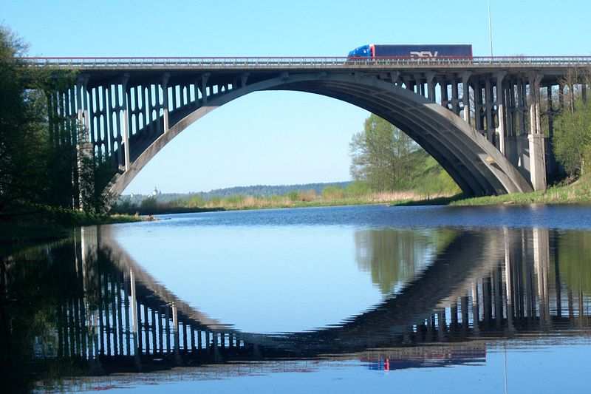](http://upload.wikimedia.org/wikipedia/commons/c/c6/Arkinis_tiltas-Arch_Bridge.JPG)With the *x* and *y* axes as shown the bridge arch has equation

*y* = $\frac{5x}{16}$ (8 – *x*)

Determine

**(a)** the width of the river flowing

underneath the bridge. **(2)**

**(b)** the clearance underneath the

bridge at the centre **(2)**